1.what is software?what is software engineering?
Software is a program or set of programs containing instructions that provide desired functionality. And Engineering is the process of designing and building something that serves a particular purpose and finds a cost-effective solution to problems.
Software engineering is the process of designing, developing, testing, and maintaining software. It is a systematic and disciplined approach to software development that aims to create high-quality, reliable, and maintainable software. Software engineering includes a variety of techniques, tools, and methodologies, including requirements analysis, design, testing, and maintenance.

2.Explain types of software
1. System software
If you think of software as being in layers, the system software is the bottom layer: it sits between the hardware and the application software.
2. Utility software
Utility software is part of the system software and performs specific tasks to keep the computer running. Utility software is always running in the background. Examples of utility software are security and optimisation programs.
Security programs include anti-virus software that scans and removes viruses. Most computers will include some sort of anti-virus software, but you can add your own.
3. Application software
This is everything else! Anything that is not an operating system or a utility is an application or app. a word processor, spreadsheet, web browser, and graphics software are all examples of application software, and they can do many specific tasks.
You can remove and add applications on your computer using the operating system.

3.What is SDLC? explain each phase of SDLC.
Software Development Life Cycle (SDLC) is a framework that defines the steps involved in the development of software at each phase. It covers the detailed plan for building, deploying and maintaining the software.
SDLC defines the complete cycle of development all the tasks involved in planning, creating, testing, and deploying a Software Product.

There are six types of phases
1.Requirement gathering and analysis
During this phase, all the relevant information is collected from the customer to develop a product as per their expectation. Any ambiguities must be resolved in this phase only.
2.Design
In this phase, the requirement gathered in the SRS document is used as an input and software architecture that is used for implementing system development is derived.
3.Implementation or Coding
Implementation/Coding starts once the developer gets the Design document. The Software design is translated into source code. All the components of the software are implemented in this phase.
4.Testing
Testing starts once the coding is complete and the modules are released for testing. In this phase, the developed software is tested thoroughly and any defects found are assigned to developers to get them fixed.
Retesting, regression testing is done until the point at which the software is as per the customer’s expectation. Testers refer SRS document to make sure that the software is as per the customer’s standard.
5.Deployment
Once the product is tested, it is deployed in the production environment or first UAT (User Acceptance testing) is done depending on the customer expectation.
In the case of UAT, a replica of the production environment is created and the customer along with the developers does the testing. If the customer finds the application as expected, then sign off is provided by the customer to go live.
6.Maintenance
After the deployment of a product on the production environment, maintenance of the product if any issue comes up and needs to be fixed or any enhancement is to be done is taken care by the developers.

4.What is DFD? create a DFD diagram on flipkart.
DFD is the abbreviation for Data Flow Diagram. The flow of data of a system or a process is represented by DFD. It also gives insight into the inputs and outputs of each entity and the process itself. DFD does not have control flow and no loops or decision rules are present. Specific operations depending on the type of data can be explained by a flowchart.

It is a graphical tool, useful for communicating with users ,managers and other personnel. it is useful for analysing existing as well as proposed system.
It provides an overview of

DFD diagram on flipkart.
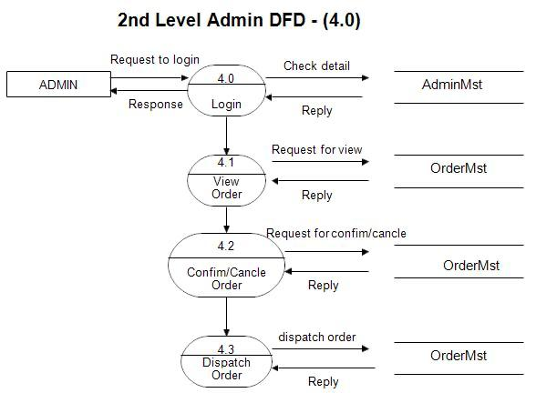

5.What is flowchart? create a flowchart to make addtion of two numbers.
A flowchart is a diagrammatic representation of steps that we have taken to solve the problem.

Below is the flowchart to find the addition of two numbers.
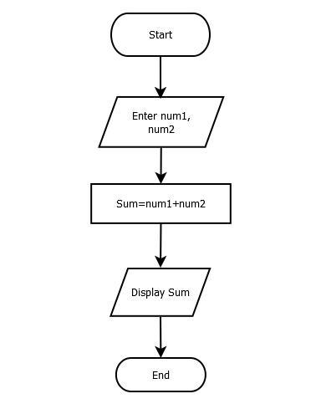

6.what is usecase diagram?create a use - case on bill payment on paytm.

Use Case Diagram for Payment. A use case diagram example developed for a Payment system. Use this design as a use case diagram example for teaching. The design can also be customized as a use case diagram template, with Visual Paradigm's use case diagram tool.
The actors that the system you are describing interacts with, the system itself, the use cases, or services, that the system knows how to perform, and the lines that represent relationships between these elements.

